MY-1200E
Automatic Die-cutting Machine
Product Introduction

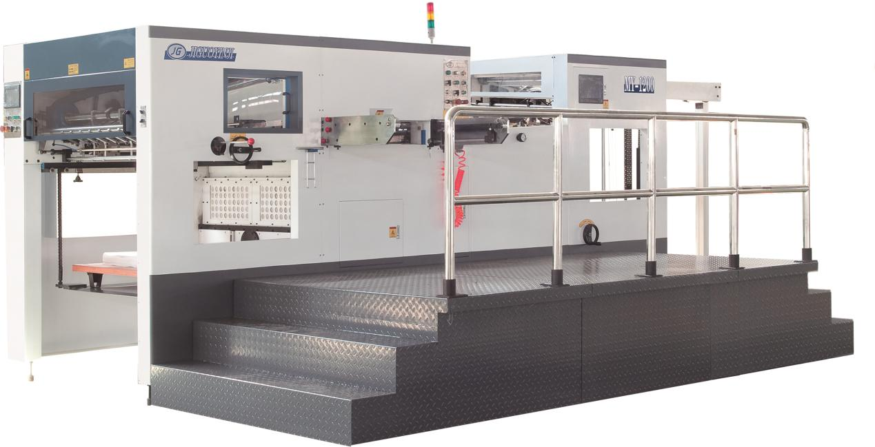

Tangshan Jiguo Printing Machinery Co.,Ltd.
en.jiguo.net

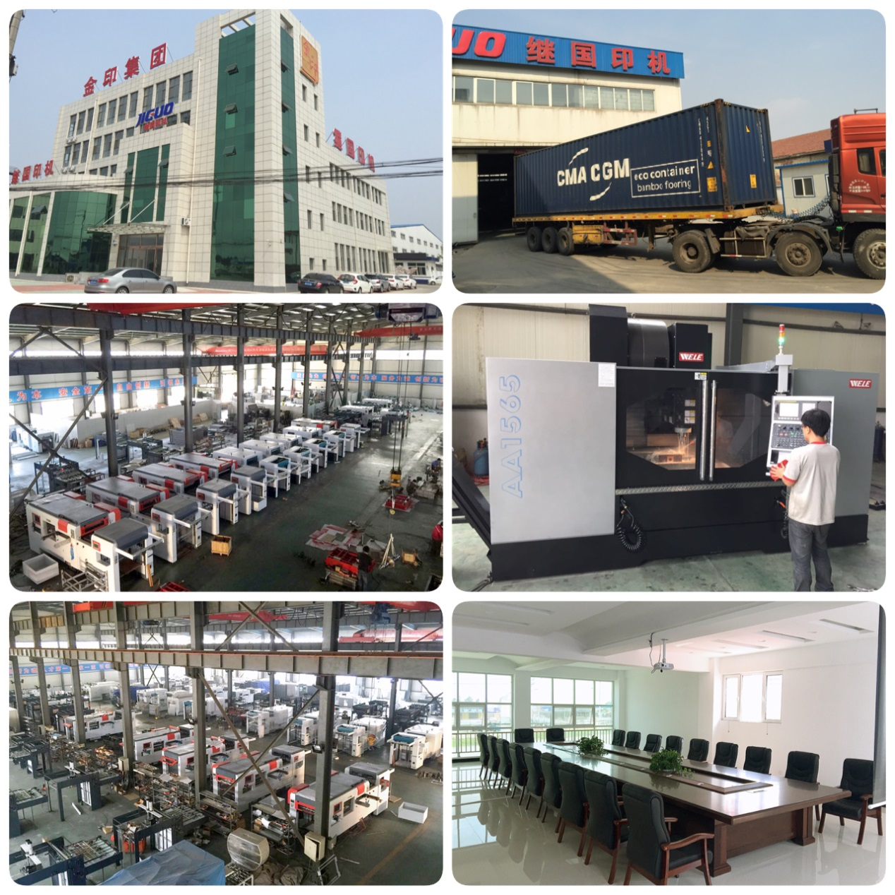
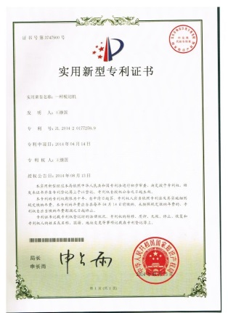
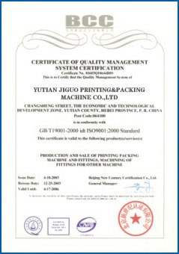
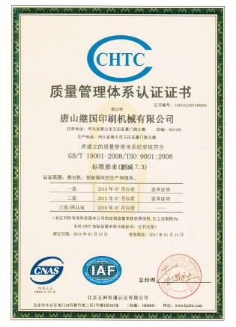
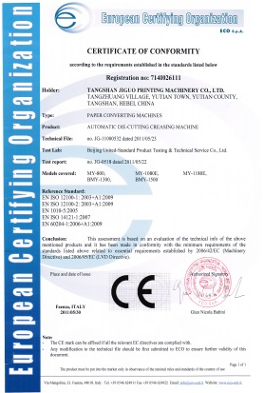

Contents

- Company Profile
- Details Specifications
- Configuration Information
- Product Introduce
- Cutting Parts
- Standard Parts
- Electrical Parts
- Standards for Assembling
- Human Culture Principle
- Description of the Entire Product
- Paper Feeding Unit and Paper Conveying Unit
- Die-cutting Unit
- Paper Collecting Unit
- Electrical Control Unit
- Machine Videos Link
- Accessories
- Accompanying documents
- Accompanying tools
- Additional accessories and consumable spares
VIII、After-sales service commitment

Company Profile
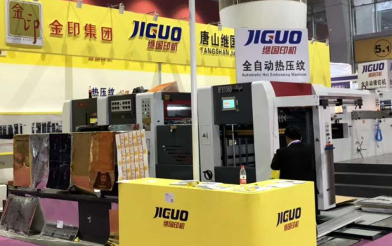
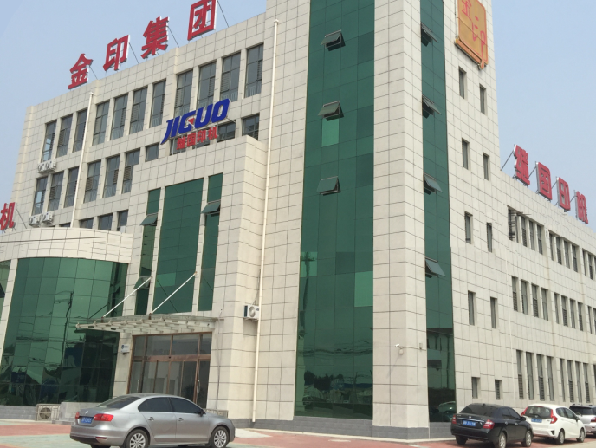
Tangshan JIGUO printing machinery Co., LTD., founded in 1996, is a high-tech enterprise started jointly by a number of senior engineers, and is located in the central area of YuTian County within the golden triangle economic zone consisted by Beijing, Tianjin and Tangshan city with 42.81 mu area covered. Our company has a technical team consisting of 160 elite personnel who contribute to our strong technical power, high level skills of design, assembly and manufacturing, perfect management system and advanced processing and testing equipment. Our company is specialized in production of post-print paper packaging equipment, and has established long-term scientific cooperation for die-cutting machine schemes with the Beijing Institute of Graphic Communication. The company is a modern enterprise incorporating the design, research and development, sales and service. There are two subsidiaries, respectively engaged in machinery parts processing and other printing equipment manufacturing, such as creasing matrix, etc.
Our company adheres to the ideas "Technology boosts enterprise” and "Create first-class products". Advanced management concepts and ideas regarding talents as the base, technology as the soul, quality as the foundation, brand as the flag, marketing as the power and service as the source of the company, contributes to rapid development of our enterprise. Our products have passed the ISO9001 quality certification and the CE certification. We are now mainly producing MY-800H/1060H/1080E/1200E/1320A/1500A/1680ASQ automatic die-cutting and creasing machine(with stripping unit), TMY-800H/1080H/1320H automatic die-cutting and foil stamping machine, BMY1320/1500/1680A Semi-automatic die-cutting machine(with stripping unit) and size 1300/1450/1600（Semi）automatic flute laminating machine, TC-760/1100/1500A/B/C Automatic windows patching machine, saw machine, creasing matrix and many other post-press equipment. Since its establishment, Tangshan JIGUO printing machines have attended hundreds of large exhibitions at domestic and abroad, and have won many honorary awards in the industry and received thousands of praises from domestic and international packaging enterprises. Attended all the big exhibition in domestic Beijing, Shanghai, Guangzhou. And the big exhibition in India, Egypt, Iran, Brazil, Turkey, Russia and so on. We have now grown into a well-known domestic post-press equipment manufacturing expert.
Since first launched in market in 1996, with stable quality and reasonable price, our products have received many praises for our quality and reputation. Our company has become an internationally famous enterprises with products sold well all over the country and exported to over 20 countries and regions, including the United States, South Korea, Russia, India, Thailand, Peru, Egypt, Turkey and so on. JIGUO die-cutting series products are the star products of our company. Taking quality as the lifeline, we have manufactured post-press die-cutting machines with superior quality, low price and high cost performance both at home and abroad. With a high starting point and high standard, we have been incessantly pursuing our dream; with excellent quality, preferential prices and excellent service, we have been cooperating with friends at home and abroad closely to obtain mutual benefit and reciprocity, and create a better tomorrow.
- Company Profile
Tangshan JIGUO printing machinery Co., LTD., founded in 1996, is a high-tech enterprise started jointly by a number of senior engineers, and is located in the central area of YuTian County within the golden triangle economic zone consisted by Beijing, Tianjin and Tangshan city with 42.81 mu area covered. Our company has a technical team consisting of 160 elite personnel who contribute to our strong technical power, high level skills of design, assembly and manufacturing, perfect management system and advanced processing and testing equipment. Our company is specialized in production of post-print paper packaging equipment, and has established long-term scientific cooperation for die-cutting machine schemes with the Beijing Institute of Graphic Communication. The company is a modern enterprise incorporating the design, research and development, sales and service. There are two subsidiaries, respectively engaged in machinery parts processing and other printing equipment manufacturing, such as creasing matrix, etc.
Our company adheres to the ideas "Technology boosts enterprise” and "Create first-class products". Advanced management concepts and ideas regarding talents as the base, technology as the soul, quality as the foundation, brand as the flag, marketing as the power and service as the source of the company, contributes to rapid development of our enterprise. Our products have passed the ISO9001 quality certification and the CE certification. We are now mainly producing MY-800H/1060H/1080E/1200E/1320A/1500A/1680ASQ automatic die-cutting and creasing machine(with stripping unit), TMY-800H/1080H/1320H automatic die-cutting and foil stamping machine, BMY1320/1500/1680A Semi-automatic die-cutting machine(with stripping unit) and size 1300/1450/1600（Semi）automatic flute laminating machine, TC-760/1100/1500A/B/C Automatic windows patching machine, saw machine, creasing matrix and many other post-press equipment. Since its establishment, Tangshan JIGUO printing machines have attended hundreds of large exhibitions at domestic and abroad, and have won many honorary awards in the industry and received thousands of praises from domestic and international packaging enterprises. Attended all the big exhibition in domestic Beijing, Shanghai, Guangzhou. And the big exhibition in India, Egypt, Iran, Brazil, Turkey, Russia and so on. We have now grown into a well-known domestic post-press equipment manufacturing expert. Since first launched in market in 1996, with stable quality and reasonable price, our products have received many praises for our quality and reputation. Our company has become an internationally famous enterprises with products sold well all over the country and exported to over 20 countries and regions, including the United States, South Korea, Russia, India, Thailand, Peru, Egypt, Turkey and so on. JIGUO die-cutting series products are the star products of our company. Taking quality as the lifeline, we have manufactured post-press die-cutting machines with superior quality, low price and high cost performance both at home and abroad. With a high starting point and high standard, we have been incessantly pursuing our dream; with excellent quality, preferential prices and excellent service, we have been cooperating with friends at home and abroad closely to obtain mutual benefit and reciprocity, and create a better tomorrow.

- Details Specifications
Specifications sheet
Model | MY-1200E
Max.paper size | 1200×780mm
Min.paper size | 400×370mm
Max.cutting size | 1170×760mm
Max.cutting speed | 7000s/h
Sheet thickness | Corrugated board : ≤4 mm  Cardboard:100-2000 gsm
Min. Gripper Edge | 8mm
Die cutting Precision | 0.15mm
Max.pressure | 320 Tons
Max. Feeding Pile | 1800mm
Max. Delivery Pile | 1600mm
Total power | 18.5Kw
Net weight | 16.8 Tons
Overall dimension | 6850×4080×2160mm

- Configuration Information
NO. | Name | Brand | Producing area & comment
1 | Main worm & worm wheel | M10 | Korean bearing steel，after quenching, wear to worm, Taiwan-owned processing
2 | Intermittent mechanism | CAMINDEXER | Taiwan
3 | Die cutting steel plate | 7mm | Korean material 75Gr1
4 | Main chain | Iwis | Germany
5 | Pneumatic clutch | OMPI | Italy
6 | High-speed joint | OMPI | Italy
7 | Screws | 12.9 level | Taiwan
8 | Bearing 30311 | SKF | Sweden
9 | Bearing 32016 | SKF | Sweden
10 | Bearing 57941/10 | SKF | Sweden
11 | Bearing 6016-2Z | SKF | Sweden
12 | Bearing 6212-2Z | SKF | Sweden
13 | Bearing 6214-2Z | SKF | Sweden
14 | Bearing 6218-2Z | SKF | Sweden
15 | Bearing 6219-2Z | SKF | Sweden
16 | Bearing 63202-2Z | SKF | Sweden
17 | Bearing 80202 | SKF | Sweden
18 | Bearing 80208 | SKF | Sweden
19 | Bearing 80209 | SKF | Sweden
20 | Bearing 80210 | SKF | Sweden
21 | Bearing 80216 | SKF | Sweden
22 | Bearing 80307 | SKF | Sweden
23 | Bearing 6311 | SKF | Sweden
24 | Other Bearings | NSK | Japan
25 | Joint bearing POS12L | SF | Korea
26 | Linear bush LM12UU | HHY | Korea
27 | Linear guide rail | HIWIN | Taiwan
28 | Encoder | OMRON | Japan
29 | Frenquency converter | TOSHIBA | Japan
30 | Programmable logic controller | OMRON | Japan
31 | Human-computer interface | WEINVIEW | Taiwan
32 | Photoconductive switch | OMRON\KEYENCE | Japan
33 | Approach switch | OMRON | Japan
34 | A.C. contactor | Schneider Electric | France
35 | Thermorelay | Schneider Electric | France
36 | Air switch | LS | Korea
37 | Button | Schneider Electric | France
38 | Oil pressure switch SNS-C106X | SAGLNOMIYA | Japan
39 | Give paper motor | WANSHSIN | Taiwan
40 | Receive paper motor | WANSHSIN | Taiwan
41 | Main Motor | SIEMENS | Germany
42 | Lubrication system | GOLDKA | China
43 | Pneumatic system | SNS | China
44 | Solenoid valve | SNS | China
45 | Vacuum pump | EUROVAC | Taiwan
46 | Relay | IDEC | Japan
For any needs of technology improvement, company keeps the right to change above information.
- Product Introduce
Our company has been engaged in the production of die-cutting machines for many years, and we are highly experienced in design, manufacture, and after-sales service etc. We have our own knowledge in this product which can be manufactured in batches, and our devices are widely distributed all over the world depending on the high standard configuration, high standard design, high quality, high speed, high safety and high cost performance.
1、 Cutting Parts
All cuttings parts are designed stably without any scamp work or stint material. The wall plate is shaped by cast steel with high tensile strength against deformation. The crankshaft is made of fully quenched chrome steel, the large worm wheel and all bearing bushes are made of alloy copper, and the worm wheel is 85mm thick (65mm commonly). The worm is made of quenched bearing steel by grinding (45# carbon steel not by grinding commonly). All other parts are made of standard 45# steel at least.
2、 Standard Parts
Imported parts and standard parts have special trademarks and they cannot be counterfeited; the high price of a die-cutting machine arises from the highly standard configuration as all bearings are from Japan SK and key parts from better Sweden SKF. It is integrated with Taiwan highly precise intermittent reduction gear, and Germany main chain, other chains are from Taiwan TY, even every a little screw is in the topmost grade 12.9, and undoubtedly they are very important for the product quality.
3、 Electrical Parts
Electrical parts are famous brand products like standard parts. The frequency governor, programmable controller (PLC computer), optical switches and other key controlling elements are from Japan. Other switches, contactors and relays are from France Schneider. The perfection of high quality die-cutting machine is originated from the world famous electrical configuration.
4、Standards for Assembling
This die-cutting machine is assembled to satisfy a high requirement, so our company has established many high standard part tolerances and assembling levels; e.g. the bearing tolerance is within 0.02mm; the hardness of each quenched part is 40° above; all bearing are assembled in the best process – hot assembling to prevent forced knocking, and each part is assembled with a clear tolerance record. When the assembled machine is operated with no load for 48 hours, the bearing temperature cannot be 15°C higher than the room temperature. No disorderly shutdown is allowable within 500 pieces of paper, and there mustn’t be any unacceptable noise from the finally assembled machine. In all, each machine is followed by a list of acceptance check, and it will not be accepted if any item is beyond the standard.
5、Human culture principle
The deep company culture make every employee know that quality is the core meaning of life, united to keep improving is the basic requirement for being a person and producing a machine, and saving money for the client, helping the client to earn money, and assisting the client in development are our service principle. We hope each client can deeply and favorably know our products. We believe that our high quality products will be one of your wealth sources.
- Descriptions of the entire product
Automatic die-cutting & stripping machine is the key device for the production of cartons, paper boxes and high standard paper products, etc. It is especially applicable to the automatic die-cutting and stripping of complicated paper boxes and cigarette cases to rationalize the production of paper boxes. This machine is integrally assembled, transported and mounted, it can be put into operated in one day, and thus the cost is reduced. The precise assembly and high configuration make it better than Taiwan machines and competitive with Japan machines.
Advantages of our die-cutting machine:
1、Paper Feeding Unit
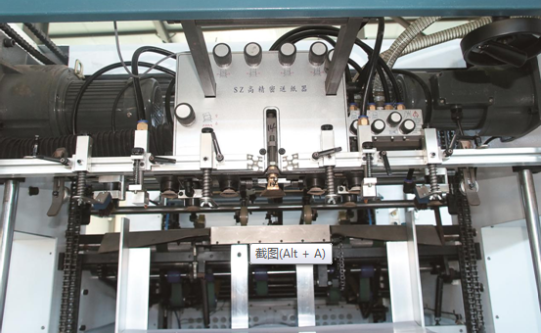
- The enlarged paper feeding head (Feeder head) has 9 suction nozzles applicable for paper in different thicknesses and 5 paper feeding nozzles which can be independently adjusted for parallel paper feeding. It also has 4 paper lifting nozzles which can move up and down in a large stroke especially applicable for small corrugated paper. The large power wind pump provides a high suction force. It can be conveniently adjusted; paper can be divided reliable, and it runs fast and stably.
- By the special secondary paper feeding and preliminary paper stacking, the primary and secondary can be shifted to ensure uninterrupted paper feeding.
- To improve the working efficiency, paper feeding and collecting are realized by Taiwan WANSHSIN dual-speed reduction motor which provides a long service life and a high torsional force, and it saves time due to its high lowering speed.
Paper Conveying Unit：
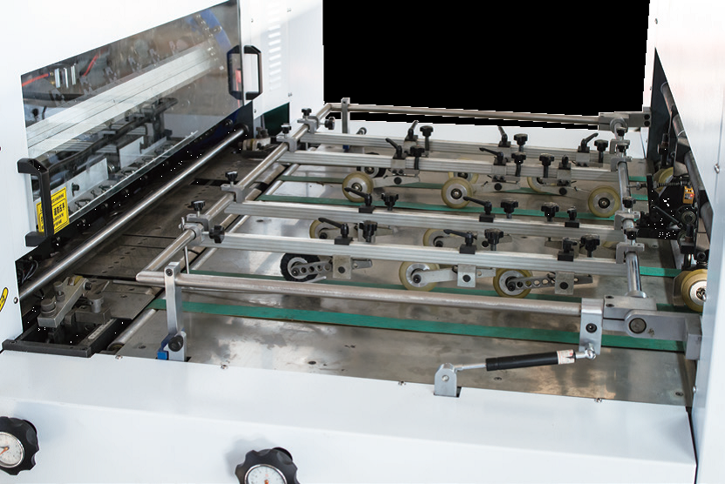
- The paper conveying part is made of stainless steel plate to prevent rust and provide stable and correct paper conveying.
- Paper is positioned by a pushing unit and a pulling unit which can be shifted conveniently for different specifications of paper.
2、Die-cutting Unit
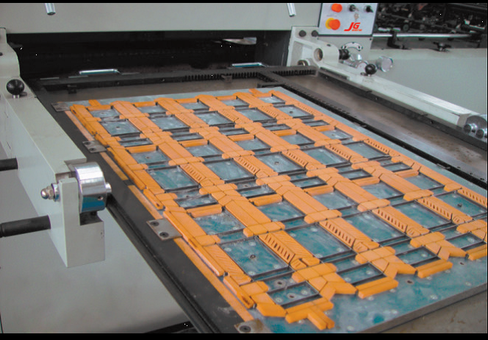
- The cast wall plate is rejected because of its low pulling force but high deformation, and steel wall plate is applied like Japan machines. The pulling force is enlarged, i.e. the pressing force is enlarged, and it becomes firm and endurable without any deformation.
- This machine is upgraded to a brand high level by the automatic pressure regulation and automatic front scale regulation. The addition of this function upgrades it into a convenient and favorable digital device with high controlling speed.
- The oil route is forcibly lubricated by a HP oil pump as made in Taiwan to reduce wearing, an oil cooler is added to cool the lubricating oil, and the main chain is lubricated timely to improve the operation efficiency.
- The novel transmission mechanism provides high speed die-cutting, and the highly precise swing link platform improves the padding speed (almost without padding), as it is known the pressure can be hardly balanced in most of other common machines.
- The pneumatic plate locking unit can fix the upper frame more firmly and faster. In our die-cutting machine, the front, back, left and right are pneumatically locked simultaneously to realize a high correctness and a high speed. However, common machines are tightened by screws.
- The paper holding rack chain is imported from Germany, which provides a long service life and a stable die-cutting precision.
- The Taiwan intermittent mechanism is the main transmission part of the die-cutting machine, and it improves the die-cutting speed and precision and reduces the device noise, while the speed and precision cannot be realized by any domestic mechanism.
- The torque limiter is equipped with overload protection. The primary and secondary units can be separated at any overload to ensure the machine can be operated safely. The Italia pneumatic brake and clutch with Japan SMC rotary joint comply with the European standard. They provide fast clutching, high and stable force, long service life and low noise.
- Paper Collecting Unit
- Paper can be collected automatically and orderly.
- The efficiency is improved by an uninterrupted paper collecting grid plate, and when paper is stacked to the specified height, the paper collecting grid plate will be replaced by another plate for uninterrupted paper collecting.
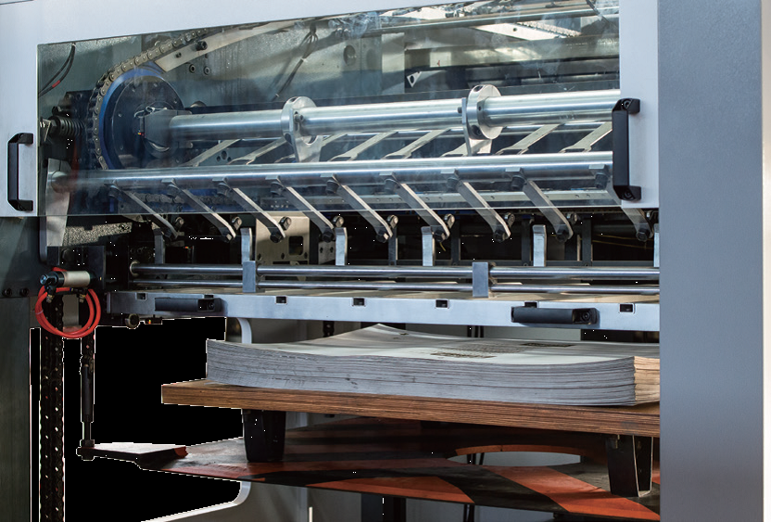
- By the pneumatic sampling, the die-cut paper can be conveniently inspected at any time.
4、Electrical Control Unit
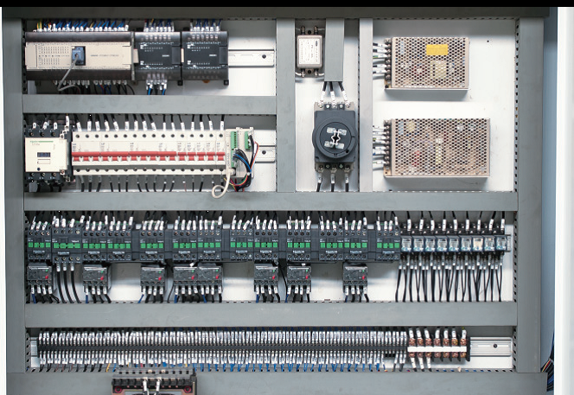
- The electrical control system is Japan Omron PLC computer automatic control for fully detecting and controlling, and the Japan Omron frequency converter with Taiwan main motor provides high power for paper feeding, paper conveying, die-cutting, and paper collecting.
- The human-machine interface can display various working conditions, indicate fault positions and give solutions.
- The machine is equipped with various safety protection units. A visible and audible alarm will be given at any fault, and the machine will be automatically shut down to protect personal and device safety.
- For the videos
- For the videos link on Youtube: https://youtu.be/jjZrFfpmyC8

- Accessories
1、Accompanying tools
Name | Quantity | Specification
Flat screw driver | 1 piece | 150
Cross screw driver | 1 piece | 150
Monkey wrench | 1 piece | 300
Allen wrench | 1 set
Socket spanner | 1 set | 6-27
Sway spanner | 1 piece
Steel plate handle | 1 piece
Hammer | 1 piece
Engine oil can | 1 piece
Pressing oil gun | 1 piece
Tool box | 1 piece

2、Additional accessories and consumable spares
SN | Name | Quantity
1 | Fixed tooth | 10 pieces
2 | Mobile tooth | 10 pieces
3 | Spring piece | 10 pieces
4 | Nozzle rubber | 16 pieces (2 sets, 1 for large and 1 for small)
5 | Paper dividing spring piece | 12 pieces (2 sets, 1 for thick and 1 for thin)
6 | Electrical banding tape | 5 pieces for large and small each
7 | Semicircular head screw M6×8 | 8 pieces
8 | Expansion bolt M8 | 2 pieces
9 | Buckle Ø30 | 8 pieces
10 | Paper feeding plate | 1 set
11 | Hair wheel (hard hair) | 4 pieces
12 | Paper dividing hair brush | 2 pieces
13 | Paper pressing plate | 1 set
14 | Torsion spring (A0714A.A0714B) Ø2.5 | 7 pieces for each
15 | Rubber padding plate 200×200 | 6 piece
16 | Pushing scale LG31.LG32 | 1 piece for each
17 | Paper barrier C0637B | 2 pieces
18 | Flexible self-adhesive tape | 1 piece

VIII、After-sales service commitment
Respected users of JIGUO printing machine:
JIGUO Printing Machine after-sales service give our heartfelt thanks to you for your choice of our products and solemnly promise you: we will provide satisfactory and considerate service for you.
In order to guarantee your normal use of the die-cutting machine and acquisition of good after-sales service, please carefully read the commitment made in this manual, for this commitment is an important accessory file delivered with user’s manual, factory certificate and packing list. It is an important basis to guarantee your after-sales service, therefore please keep this manual and act in accordance with provisions in this manual.
A. Our company has executed an all-the-way tracking management system during the period from product delivery to expiration date. Specific measures are as follows:
1、Establishing product technical record management system:
One set of documents for each machine, including acceptance certificate of assembled products, product delivery status, responsible personnel of product installation and commissioning, usage training and qualification certificate, warranty, record of technology and quality status during the guarantee and maintenance period and record of analysis and problem solving process, which can ensure guaranteed operation of each die-cutting machine sold.
2、After-sales service guarantee system
- Equipment installation and commissioning:
Our company will send professional engineers responsible for equipment overall installation and commissioning.
- Technical training:
After equipment arrives at your place, we will provide free training to two operators with technical training materials specially compiled. Professional trainers will be responsible for the training. Main training contents are:
Structure introduction of the die-cutting machine, structure and adjustment method of paper feeding, structure of the mainframe, adjustment method of the die-cutting pressure, structure and adjustment method of paper collection, installation of die-cutting plate and plate placing method, usage and attentions of various operating switches, daily maintenance and other courses.
After the training is completed, assessment of theory and practical operation will be given to operators to see whether they can operate machine skillfully and have understood principle of mechanical properties. Certificate will be given to operators who can carry out routine operations and maintenance. This certificate makes final decision on whether operators can become trainers in order to ensure the normal operation of machine later.
- Time-limited maintenance:
If temporary fault occurs in mechanical system, technical service personnel would make phone call to inquire and solve the problem on receipt of your notice. For unsolved problem, technical service engineers would arrive on your scene within 24 hours if the scene is within 150km of our company; if it is not, engineers would arrive in 48 hours (only for domestic market).
- One year of free repair guarantee,and one years of warranty, provided the spare parts during guarantee free of charge. and lifetime quality assurance:
From the day of your purchase, our company will provide you with free commissioning, maintenance and parts replacement service within one year, but we will charge cost of main parts if the accidents are caused by improper operation instead of mechanical quality.
After guarantee, we will provide technical support for all faults occurred in your machine and charge for repair service, including fault repair and original parts replacement.
B. This guarantee has legal effect and will not become invalid from company’s development and change.
C. Guaranteed by the JIGUO brand, we will continue to provide quality guarantee commitment to you.

